4)

this

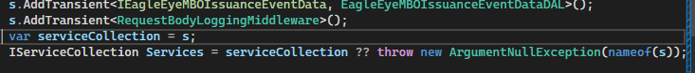

To this

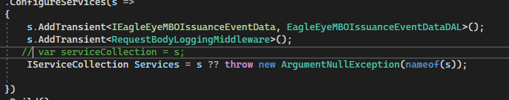

Or else

Don’t want to check null we can comment this

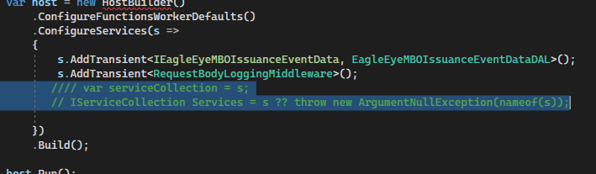

5) only response middleware is there not request middleware available.we have to create this middleware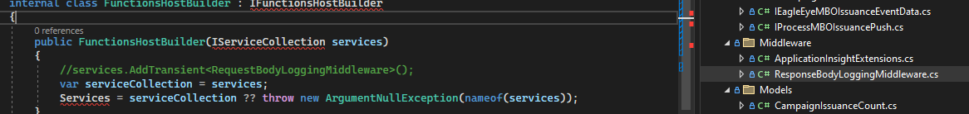

6) if this not used for compilation have to remove.

This

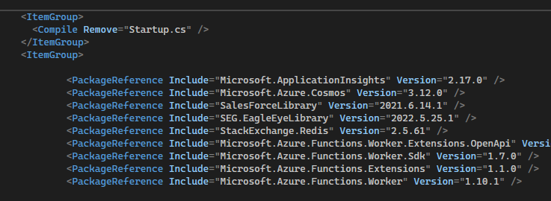

To

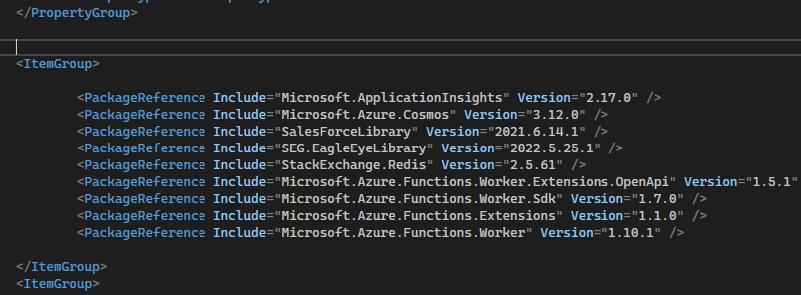

7) this is using in model,so we have to check should remove or not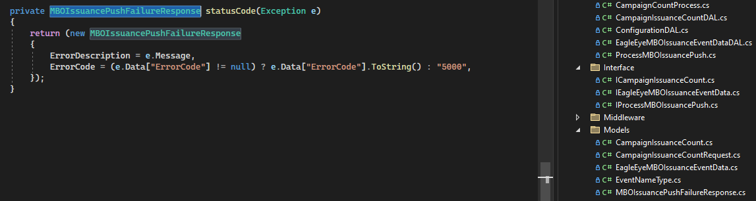

8) this get and set property name in eagleeyemboissuanceevent data in case sensitive.default value will be false so have to set true;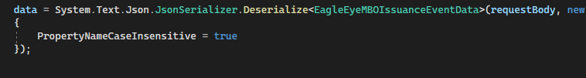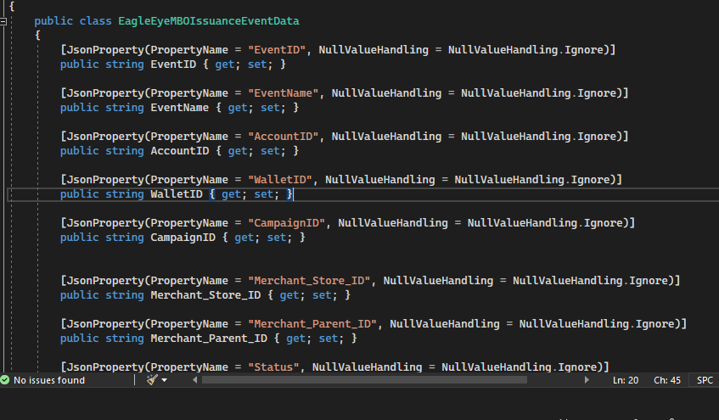

9) this

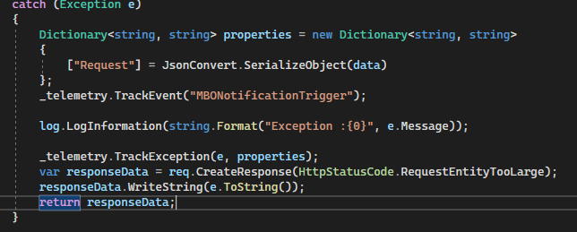

To

